DAY 29 REPORT:
TASK Description: Select a dataset from Kaggle with a single output column and create an interactive Power BI dashboard by comparing the output column with all other columns in the dataset. Use various visualizations, KPI cards, and slicers to analyze relationships, identify patterns, and generate meaningful insights from the data.
Objective:
The objective of this task is to analyze healthcare data and develop an interactive Power BI dashboard to identify patterns in patient test results. The dashboard compares various factors such as age, gender, medical condition, medication, admission type, hospital, insurance provider, blood type, billing amount, and room number against patient test results (Normal, Abnormal, and Inconclusive).
Dataset Description
The dataset contains patient healthcare information with the following attributes:
- Name
- Age
- Gender
- Blood Type
- Medical Condition
- Date of Admission
- Doctor
- Hospital
- Insurance Provider
- Billing Amount
- Room Number
- Admission Type
- Discharge Date
- Medication
- Test Results
The primary output variable used for analysis is Test Results, categorized as:
- Normal
- Abnormal
- Inconclusive

Dashboard Components
KPI Cards
The dashboard includes the following key performance indicators:
- Total Patients: 40.235K
- Total Room Records: 55.5K
- Total Billing Amount: 1.42 Billion
- Total Doctors: 40.341K
- Total Hospitals: 39.876K
These KPIs provide an overview of the healthcare dataset and help users quickly understand the scale of the data.
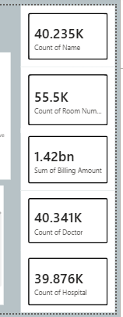

Visualizations and Analysis
1. Gender vs Test Results (Stacked Column Chart)
This chart compares male and female patients based on their test results.
Observation:
- Both genders show a nearly equal distribution of Normal, Abnormal, and Inconclusive results.
- No significant difference is observed between male and female patients.
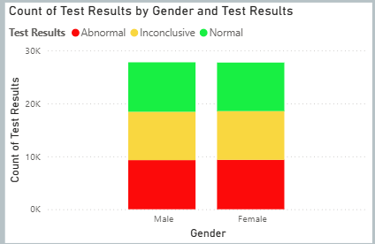

2. Test Results Distribution (Donut Chart)
This visualization displays the overall proportion of test results.
Observation:
- Abnormal, Normal, and Inconclusive results are distributed almost equally.
- The dataset is balanced across all three categories.
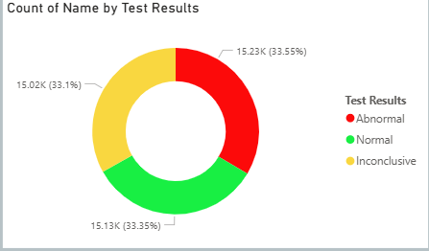

3. Year-wise Test Results Analysis (Area Chart)
This chart analyzes patient records across different years.
Observation:
- Patient counts increase gradually from 2019 to 2023.
- Similar trends are observed across all test result categories.
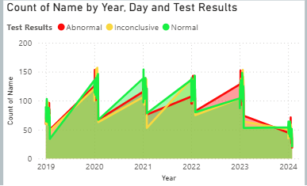

4. Medical Condition vs Test Results (Clustered Bar Chart)
This chart compares medical conditions with patient test outcomes.
Observation:
- Conditions such as Asthma, Obesity, Cancer, and Diabetes appear frequently.
- Test results are distributed across all medical conditions, indicating that abnormalities occur under multiple health conditions.
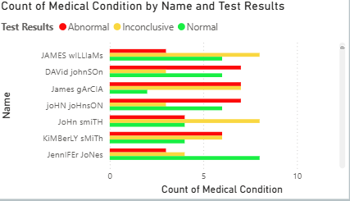

5. Medication vs Test Results (Clustered Column Chart)
This visualization analyzes medications prescribed to patients and their corresponding test results.
Observation:
- Medications such as Lipitor, Ibuprofen, Aspirin, Paracetamol, and Penicillin show similar patient counts.
- No medication dominates a specific test result category.
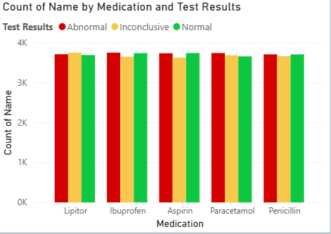

6. Blood Type vs Test Results (Treemap)
This chart visualizes blood groups and their associated test results.
Observation:
- All blood groups are represented in the dataset.
- Test results are distributed across every blood type.
- No specific blood group shows a strong concentration of abnormal results.
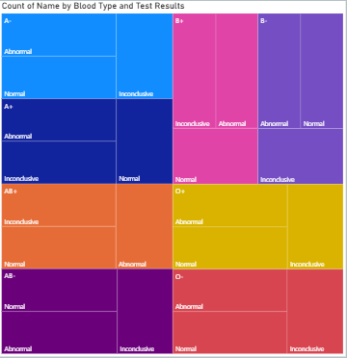

7. Admission Type vs Test Results (Stacked Bar Chart)
This chart compares Emergency, Urgent, and Elective admissions.
Observation:
- Emergency and Urgent admissions contribute a large number of patient records.
- All admission categories contain a mix of Normal, Abnormal, and Inconclusive results.
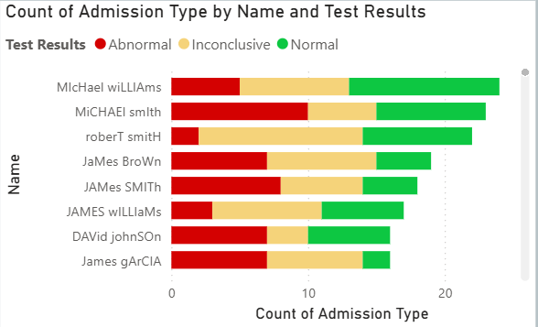

8. Billing Amount vs Test Results (Column Chart)
This chart compares the total billing amount for each test result category.
Observation:
- Billing amounts are nearly equal across Normal, Abnormal, and Inconclusive categories.
- Healthcare costs are distributed consistently among patient groups.
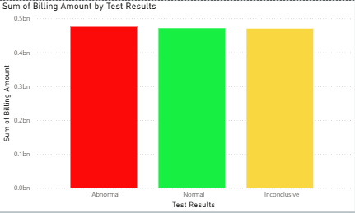

9. Room Number Analysis (Decomposition Tree)
The decomposition tree breaks down patient counts by Test Results and Room Numbers.
Observation:
- Patient records are distributed across various rooms.
- The visualization enables interactive exploration of room-level healthcare data.
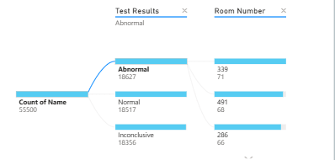

10. Monthly Test Results Trend (Line Chart)
This chart shows monthly patient distributions by test result category.
Observation:
- Monthly trends remain relatively stable.
- Small fluctuations are visible, but no extreme peaks occur.
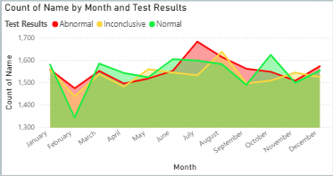

11. Doctor vs Test Results (Clustered Bar Chart)
This chart analyzes patient outcomes handled by different doctors.
Observation:
- Patient counts are distributed among multiple doctors.
- Doctors manage patients across all test result categories.
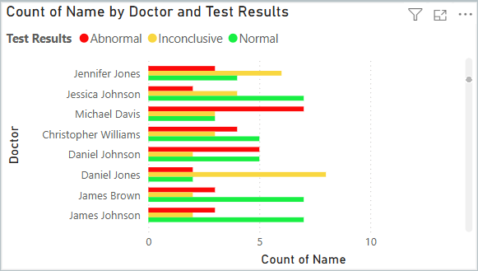

12. Hospital vs Test Results (Clustered Bar Chart)
This visualization compares hospitals based on patient test results.
Observation:
- Several hospitals contribute similar patient volumes.
- Test result patterns remain consistent across healthcare facilities.
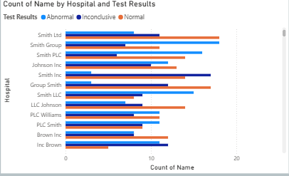

13. Insurance Provider vs Test Results (Clustered Bar Chart)
This chart compares insurance providers and patient outcomes.
Observation:
- Providers such as Aetna, Blue Cross, Medicare, Cigna, and UnitedHealthcare show similar patient distributions.
- No provider is associated with a significantly different test result pattern.
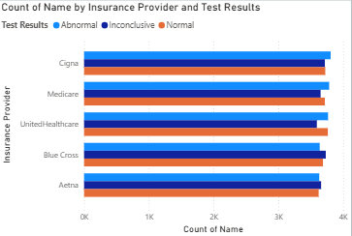

14. Age vs Test Results (Stacked Column Chart)
This chart analyzes patient age against test results.
Observation:
- Patients across all age groups are represented.
- Normal, Abnormal, and Inconclusive results appear throughout the age range.
- Middle-aged adults contribute a large portion of the patient population.
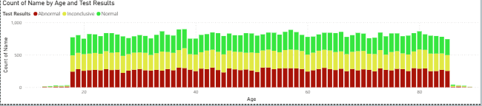

Key Insights
- Test results are distributed almost equally among Normal, Abnormal, and Inconclusive categories.
- Gender does not significantly influence test outcomes.
- Medical conditions such as Asthma, Diabetes, Obesity, and Cancer account for a substantial portion of patient records.
- Billing amounts are comparable across all test result categories.
- Blood type does not show a strong relationship with abnormal test outcomes.
- Hospitals, doctors, and insurance providers display similar patient distributions.
- Patient records are spread across a wide age range and admission types.
- The dashboard provides a comprehensive overview of healthcare performance and patient outcomes.

OVERALL DASHBOARD:
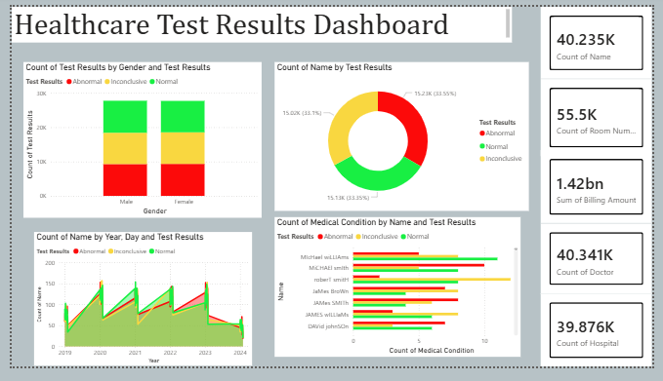
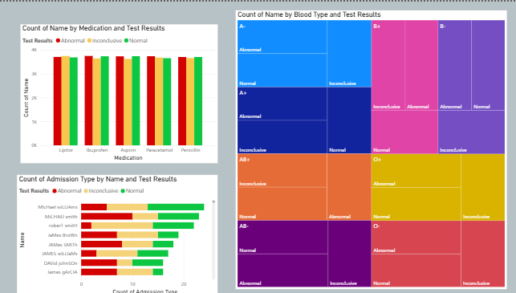
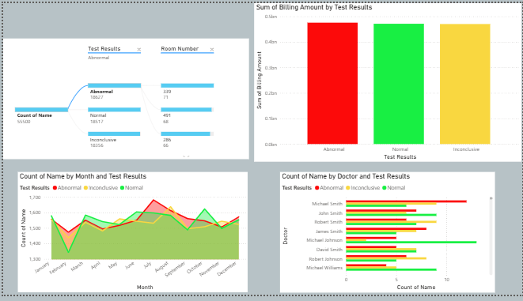
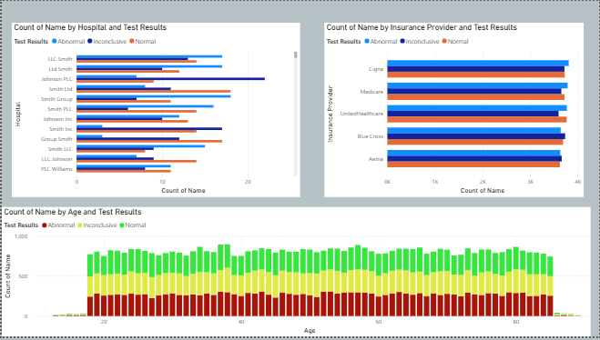

Conclusion
The Healthcare Test Results Dashboard successfully visualizes patient healthcare data and provides meaningful insights into test outcomes. Through interactive KPI cards, charts, and decomposition analysis, the dashboard enables effective exploration of relationships between demographic, clinical, and operational factors and patient test results. The analysis reveals balanced distributions across most categories, indicating consistent healthcare records throughout the dataset. This dashboard serves as an effective tool for monitoring patient information, understanding healthcare trends, and supporting data-driven decision-making.

